Gospel Illusion

Last Modified
Saturday, September 19, 2015 at 12:00:56 PM
Document Revision: 31

Information Page

I <Your Name here>, Solemnly swear never to reveal how any of my tricks are done. Nor will I ever do any trick twice in a row for the same audience. No matter how much they beg or threaten. I will be true to my secrets.

Table of Contents
Table of Contents i
1. Three ropes become the same length – all sin is equal 1
1.1. Holding the ropes 1
1.2. Presentation 3
2. Tear and restore the Bible 4
2.1. Materials 4
2.2. Folding 4
2.3. Presentation 6
3. Holy Bible Coloring Book 11
3.1. Routine by Charles A. Wormsley 11
3.2. Routine by Andrew Pitonyak 12
4. Simple Paper Tricks 13
4.1. The Pastor, Nazi, and the Thief 13
The Story 13
Alternate 15

Three ropes become the same length – all sin is equal
This trick uses three ropes. I use ropes of approximate lengths:
- short – 13 inches
- medium – 27.5 inches
- long – 43 inches
The length of the ropes are not as important as ratio of the rope lengths. The important thing is that the length of the short rope added to the length of the long rope is just a bit longer than twice the length of the medium rope.

Holding the ropes
For illustrative purposes, the short rope is red the rest are white.
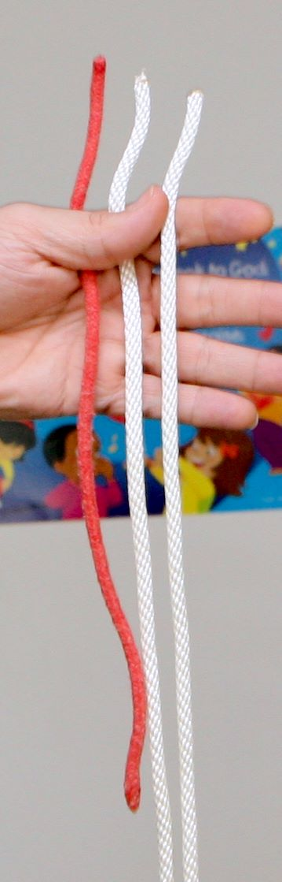  Figure 1. Short, Medium, Long | 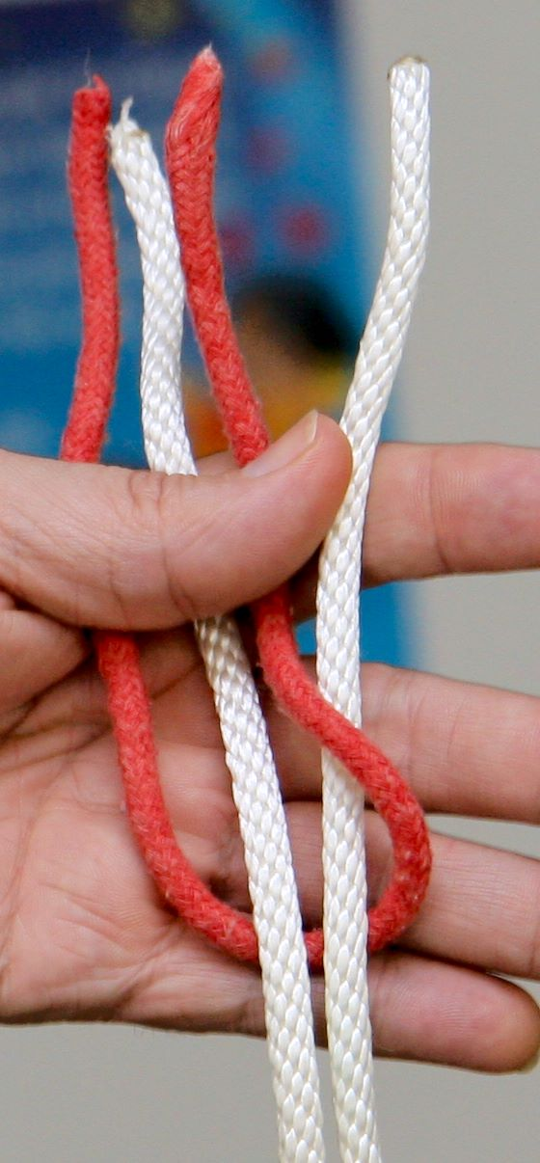  Figure 2. | 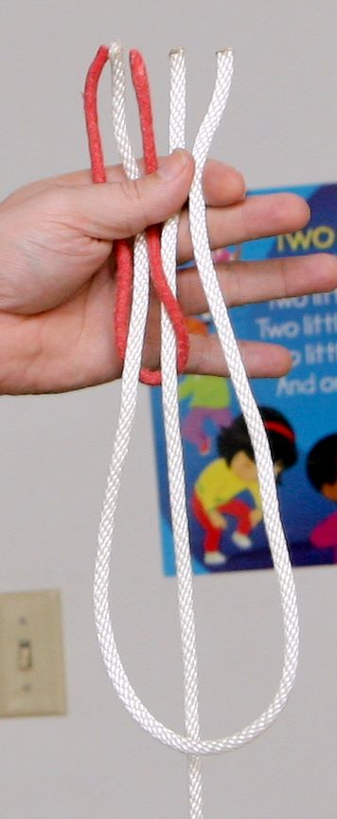  Figure 3

- Place the short, medium, and long rope in your hand as shown in Figure 1; long rope on the right.
- Take the bottom of the short rope behind the medium and the long rope, around the long rope to the front, and place it between the medium and the long rope (see Figure 2).
- Take the bottom of the medium rope in front of the long rope and place it to the right (see Figure 3).
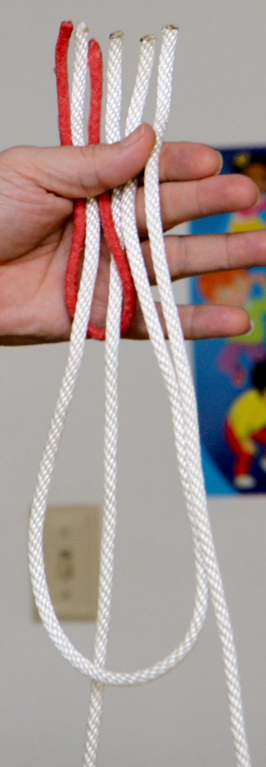  Figure 4 | 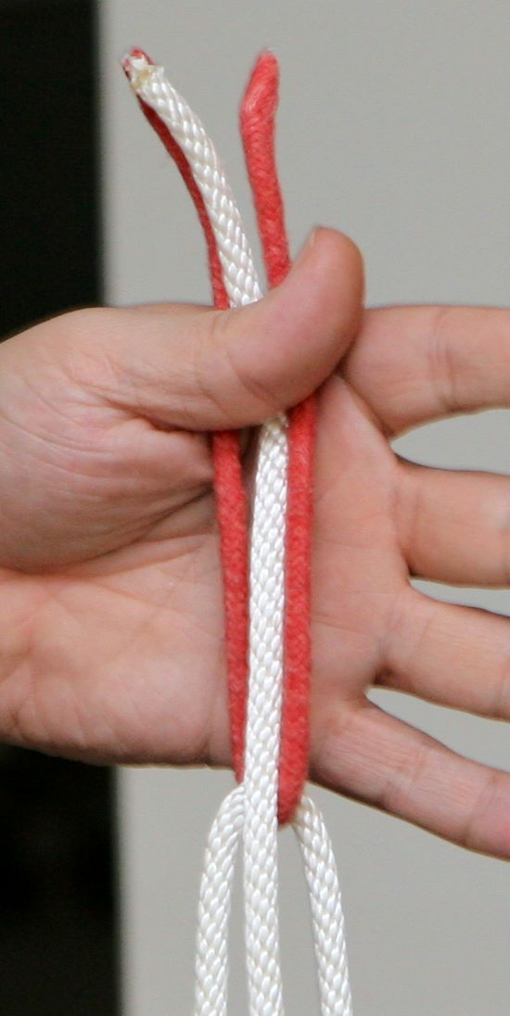  Figure 5 | 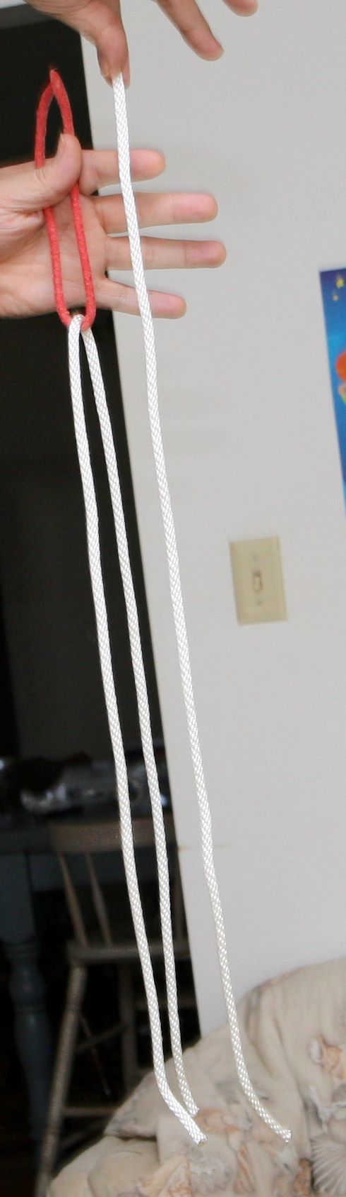  Figure 6

- Take the bottom of the long rope and bring it up to the far right (see Figure 4).
- Grab the rightmost three ropes and pull them down (see Figure 5).
When you grab the rightmost three ropes, you are grabbing both ends of the long rope and one end of the medium rope. When they are pulled down, this means that medium rope is hanging freely. The long rope is hanging over the short rope. Since the length of the short rope plus the length of the long rope are roughly twice the length of the medium rope, when they are both folded in half, the length is about the same as the medium rope (see Figure 6).
Hint: While arranging the ropes, you want to be sure that when the short rope is brought around, the bottom of the short rope is in the middle of your hand so that you cannot see that the long rope is hanging from the short rope.

Presentation
As I add the short to long ropes I discuss little sins to bigger sins. Even the fourth and fifth graders appreciate the sins as:
- You stole a cookie from the cookie jar (short rope).
- You stole the entire cookie jar (medium rope).
- You stole a cookie truck full of cookies (long rope).
- Talk about sin as you play with the ropes placing them order.
- Discuss that to God all sins are the same and even one keeps you out of heaven as you pull them to the same length.

Tear and restore the Bible
My usual presentation discusses the Bible. I mention things such as
- Some people do not know about (tear).
- Some people tell lies about the Bible (tear).
- Ramble on about the importance of the Bible as you restore it
I have also done this trick where I restore it to say Jesus rather than the Bible. You could have it start as Jesus while discussing the crucifixion but then restore it as something like “he is risen”.

Materials
I use the following materials
- Paper
  - I use letter size, but A4 would work just fine.
  - I use 20 lb paper. It must be thick enough that you cannot easily see through the paper, but thin enough that you can fold it and tear it.
  - I use Golden Rod color because it is dark enough that it obscures what is behind it and light enough that the black writing shows through.
- Elmer's No-Wrinkle Rubber Cement (or equivalent).
I use a template that is printed in landscape (not portrait) with the word Bible on it three times. Position the lines such that when you cut the paper into three equal sized pieces, the word Bible is centered horizontally and vertically on each strip and each strip looks roughly the same. Now, cut the strips.

Folding
Although it is not important that you fold exactly as I fold, it is important that you fold exactly the same way every time if you expect to be able to repeat the trick the same way every time. In this sequence, I will fold two strips and then connect them.
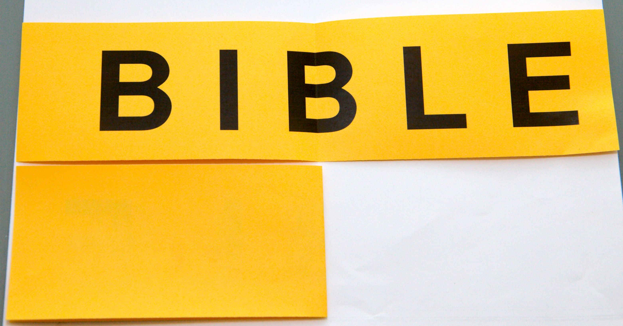  Figure 7. Fold right side over so “BI” is on the bottom. | 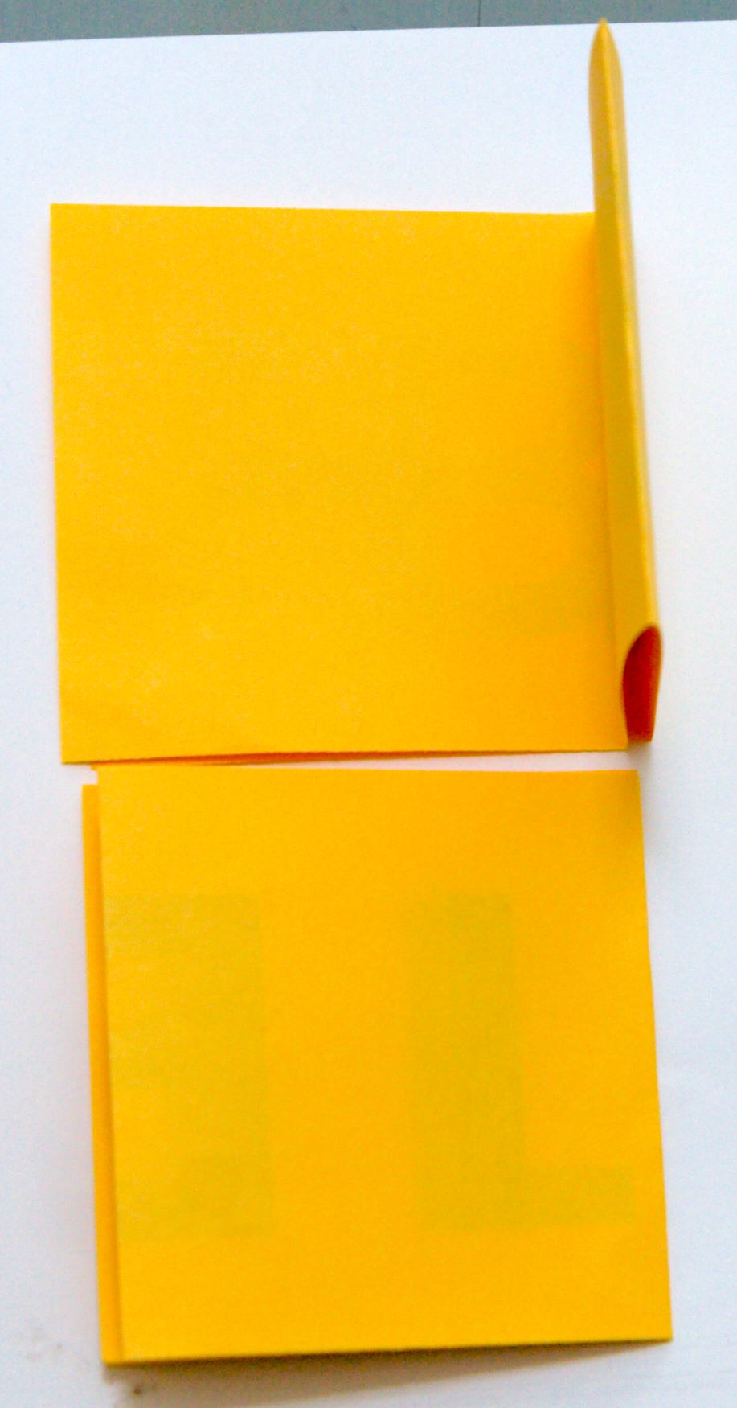  Figure 8. Fold in half again.

- Lay two identical strips on the table with the same orientation. In other words, they both read “BIBLE” from left to right.
- Fold both strips in half by folding the right side on top of the left side (see Figure 7). The E is now on top of the left-most B and the L is on top of the I. The center B is folded in half.
- Fold both strips in half by folding the right side on top of the left side (see Figure 8). If you look, the first B is on the bottom.
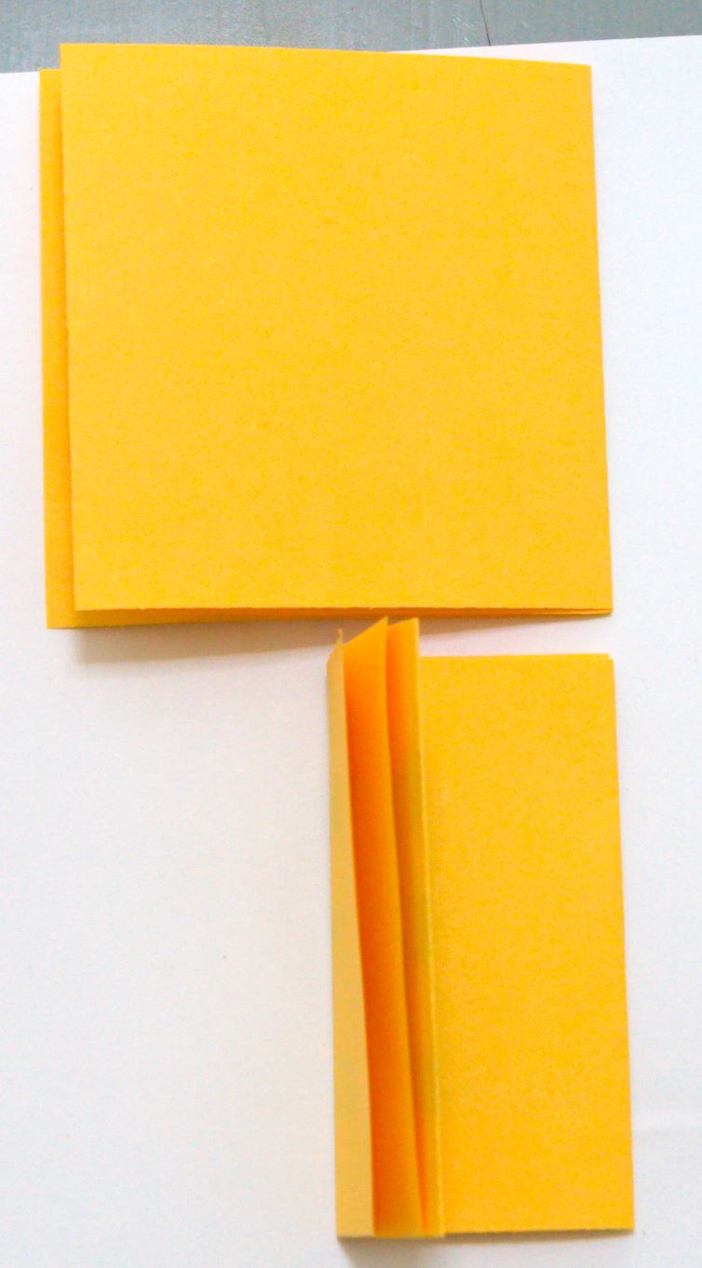  Figure 9. Fold bottom only. | 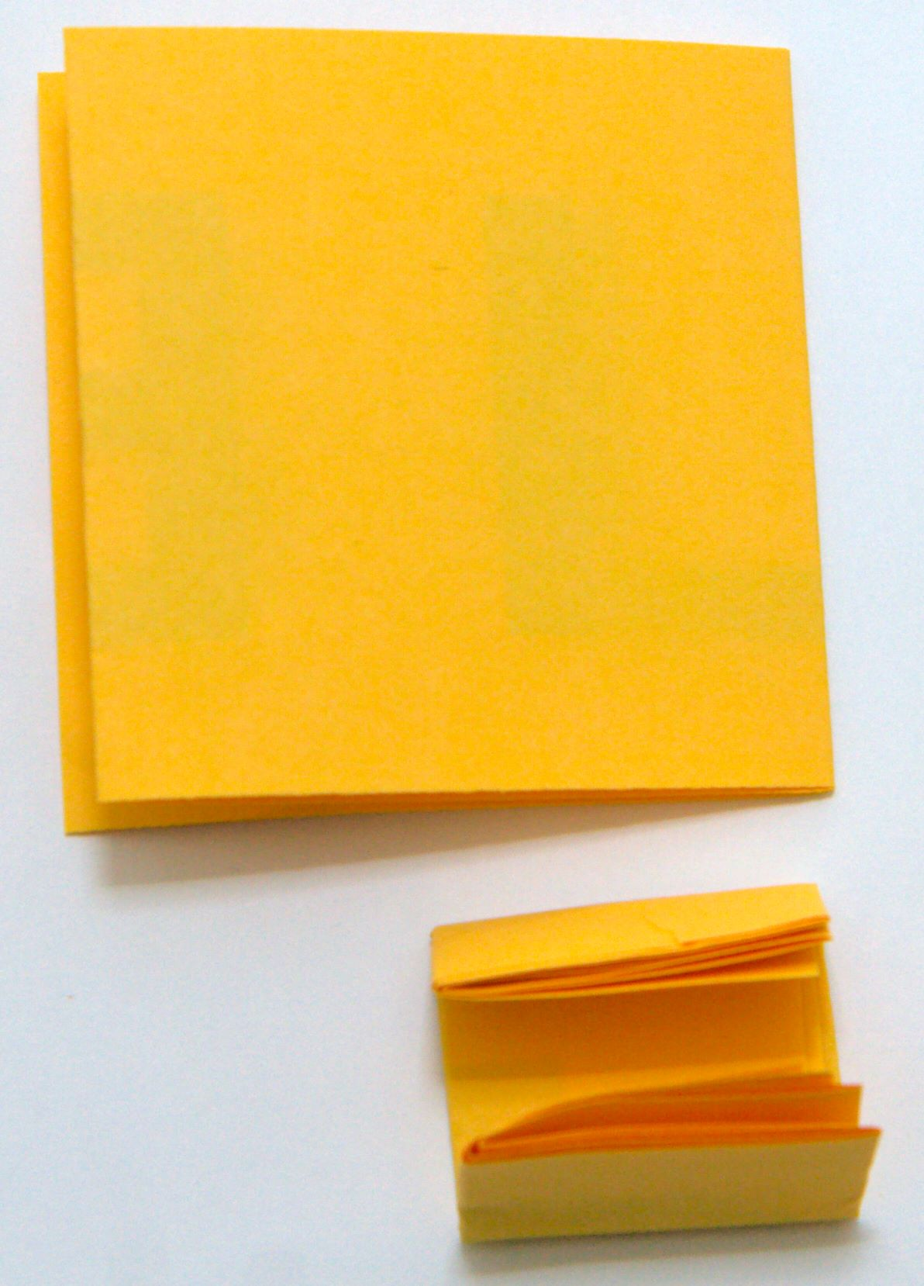  Figure 10. Fold bottom only. | 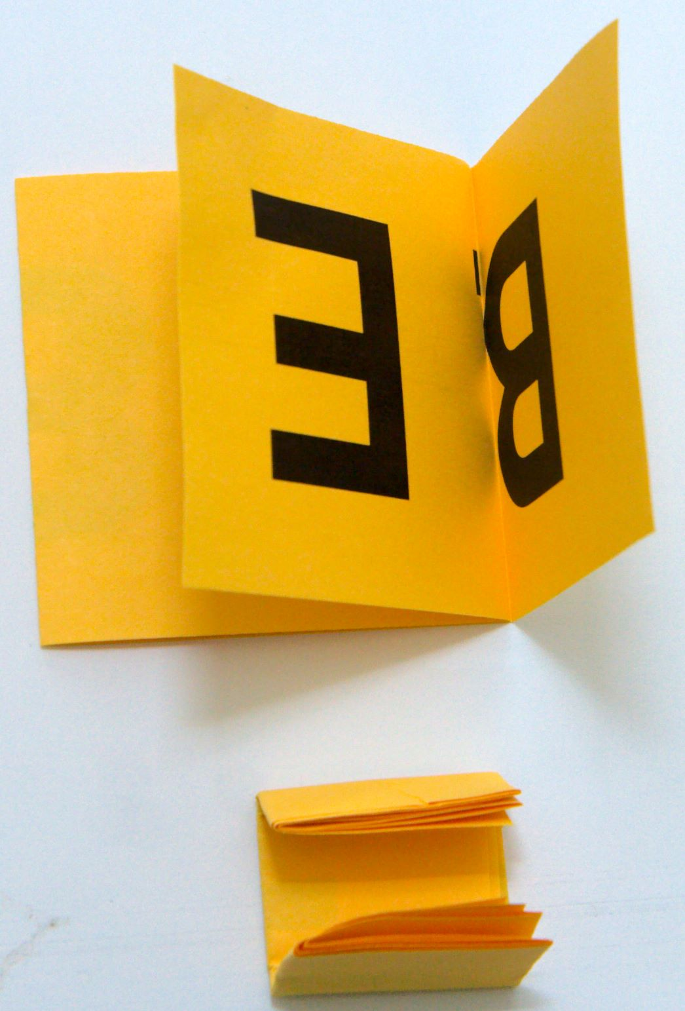  Figure 11. Flip top one only.

- The top strip is finished. Fold the bottom strip in half by folding the left side on top of the right side (see Figure 9). The last fold is roughly along the left edge of the letter B (not that it matters).
- Fold a quarter to a third of the top down and the bottom up (see Figure 10).
- Flip the top piece over by grabbing the top and flipping it towards you. This places the first B upside down on the top (see Figure 11). The letter B on the bottom piece is still right side up.
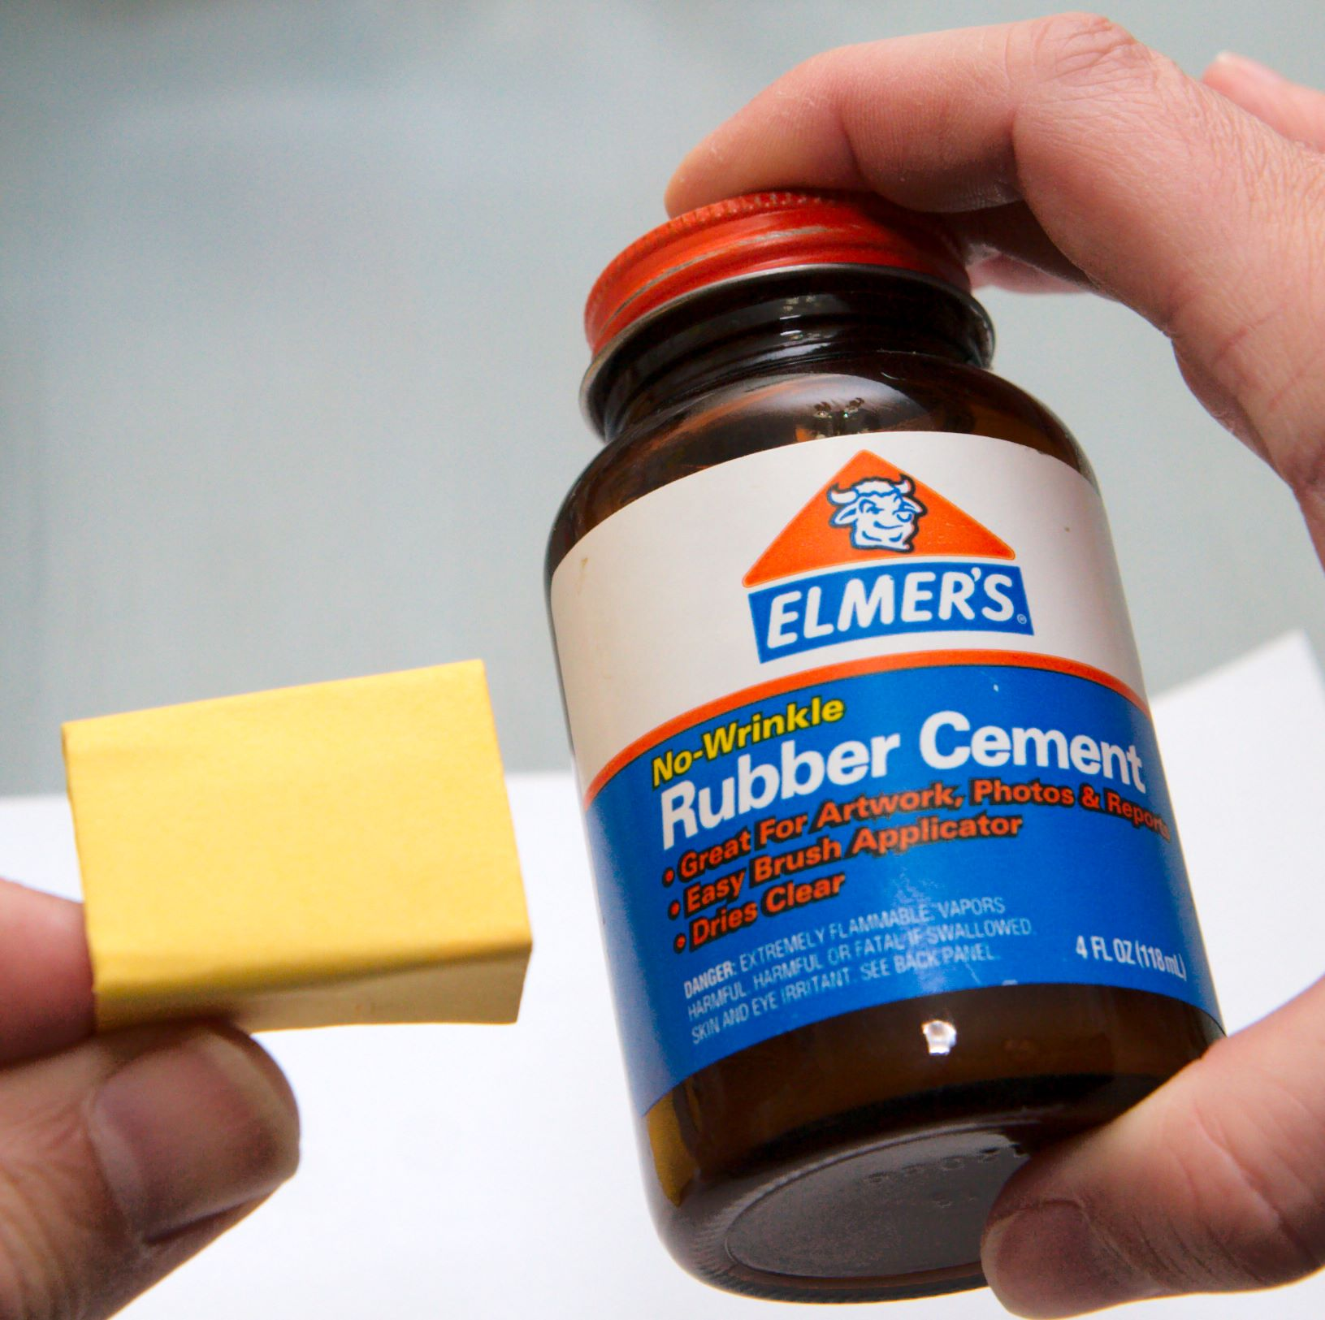  Figure 12. Use rubber cement. | 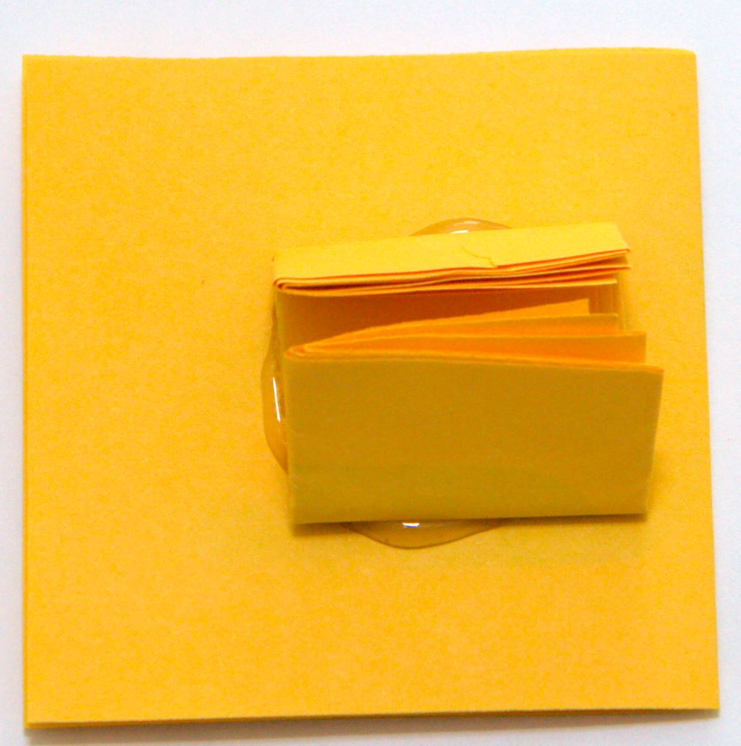  Figure 13. Let it dry.

- I use Elmer's rubber cement and place some on the bottom strip (see Figure 12).
- Glue the bottom strip to the top strip in the same orientation used in Figure 11 (see Figure 13).
At this point, the first B from each strip is back to back glued together with one upside down and the other right side up. When it dries you are ready for performing the trick.

Presentation
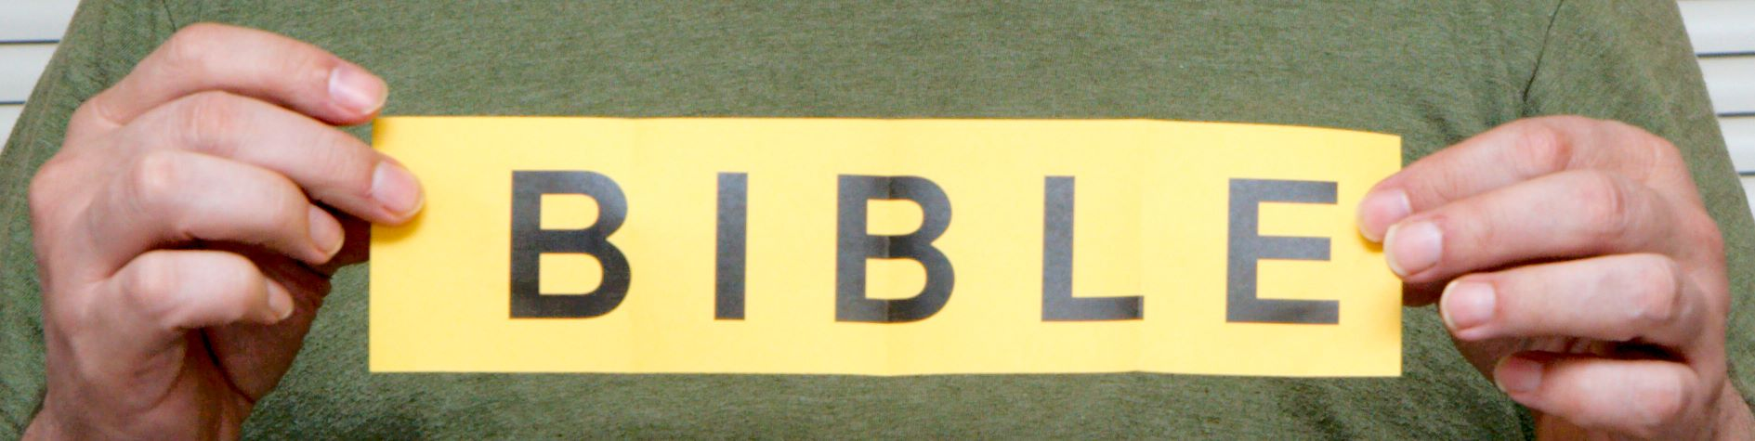
Begin the presentation by holding the paper with the fewest folds in front of your chest. Be careful that the folded up piece of paper on the back is not visible. A strong back-light or over-head light may allow the audience to see the extra paper on the back.
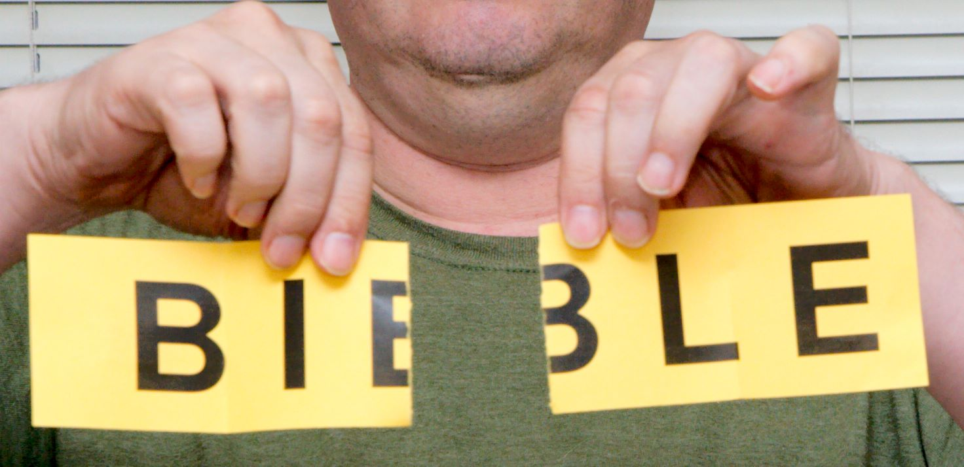
Rip in the middle along the center fold.
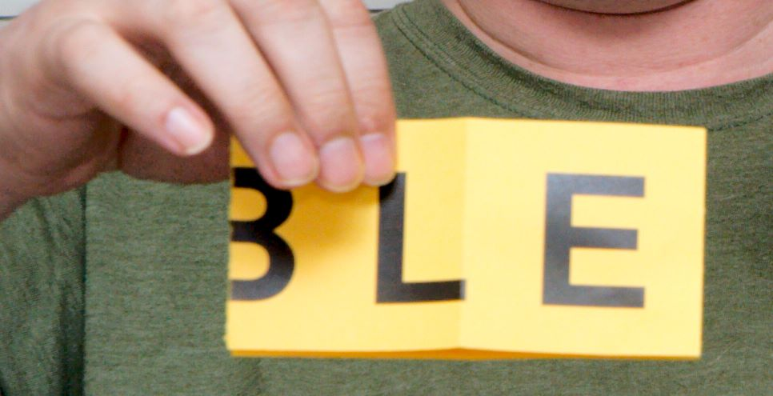
Place one piece on top of the other
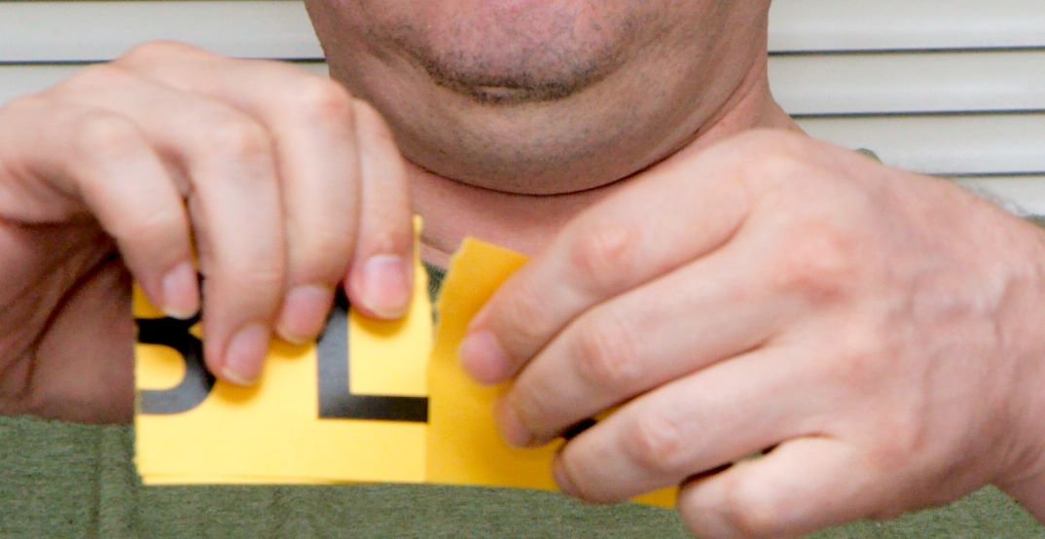
Rip again along the fold and place the pieces in a stack as you did last time you ripped.
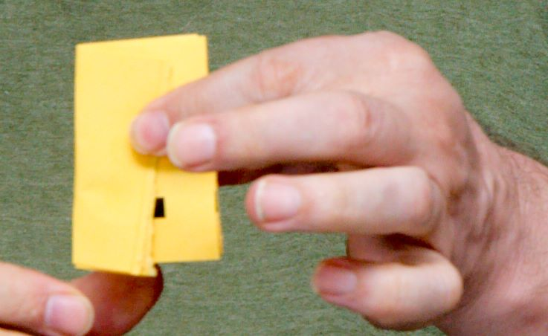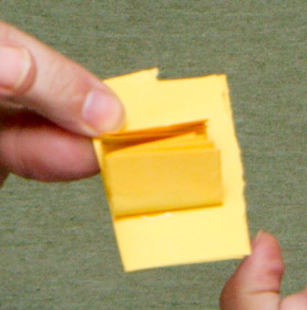
You now need to start folding the ripped pieces. It does not really matter how you begin folding, but, in the left most picture I opted to fold from the audience's left over. You can see this in the left image. The right image shows how this looks from the back. Very specifically, I folded directly next to the edge of the piece on the back. What matters is that however you fold, you do it along the edge of the back piece and you must do this for each fold.
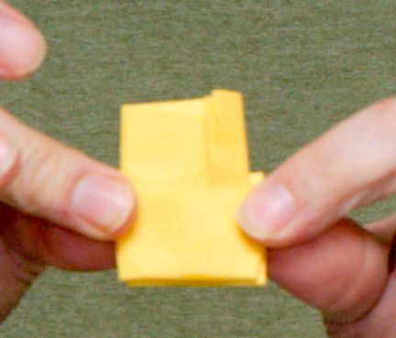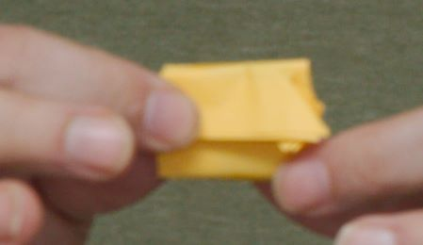
Remember, these images are showing what the audience sees. After folding from the left, a fold is made on the right (not shown), and then a fold from the bottom up is done (above image left) followed by a fold from the top down (above image right).
As I make the last fold, rotate the from top to bottom or from bottom to top. This will take that front piece that is ripped and folded and right side up and the back piece that is folded, not ripped, and upside down and exchange them such that the not ripped piece is in front and right side up. If you chose to do your initial folds and gluing in some fashion other than as described, then the orientation will be wrong. Although not catastrophic, the trick will not flow as well (in my opinion).
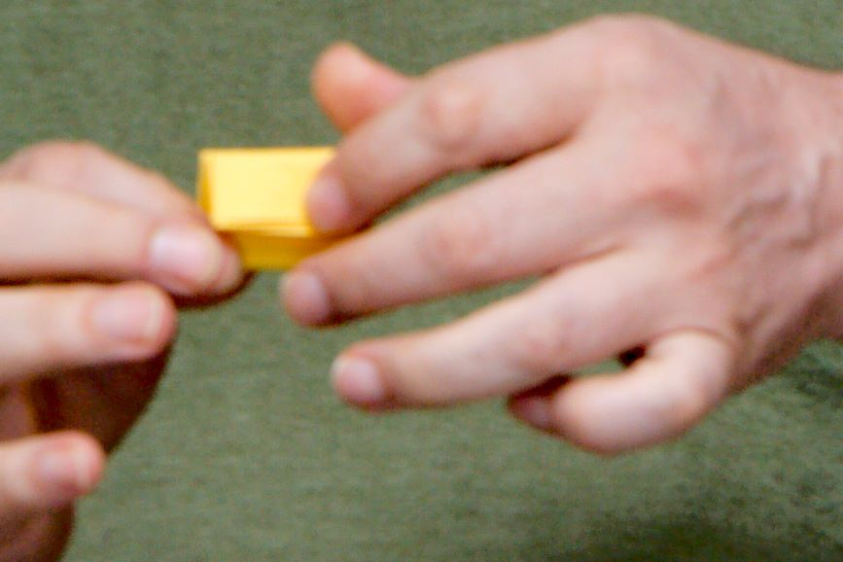 | The image on the left is immediately after the flip and it looks the same (mostly) as just before flip.  As shown, I am beginning to unfold the paper. Remember, the audience looks where you look, so you need to practice so that you can do this naturally without staring intently at anything that might give you away.  The folds on the ripped portion should hold it in place as you unfold.

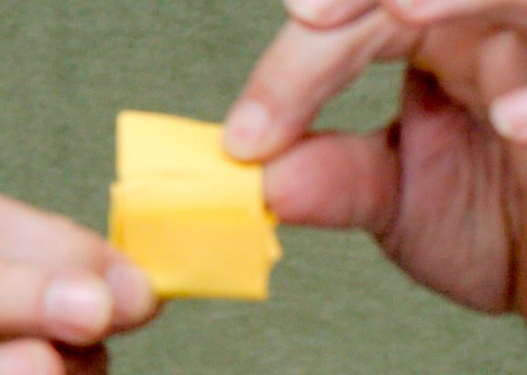 | 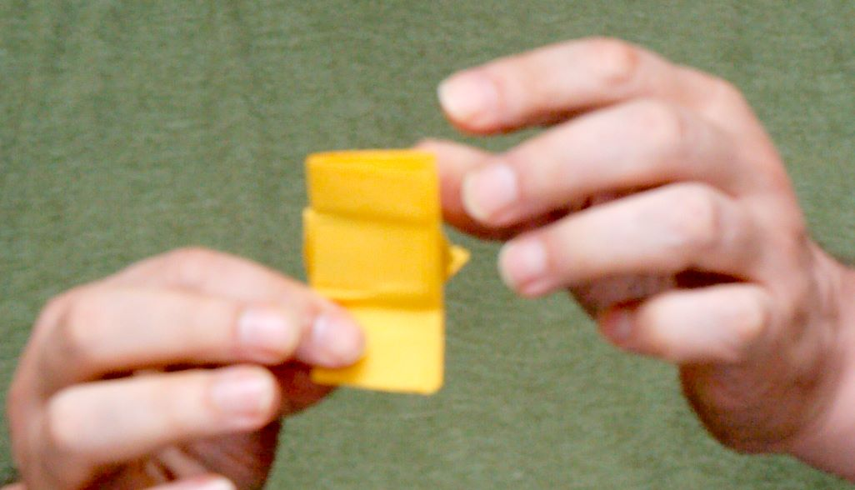

As I unfold the sheet, you can see small bits of the torn and folded piece on the back. Don't stare at them and bring attention to them. If I had not mentioned it, you would not have even noticed them at this point. So, don't stress about it, just do it. The important thing is that you do not move your hands in such as way that they can see from the side, top, or bottom.

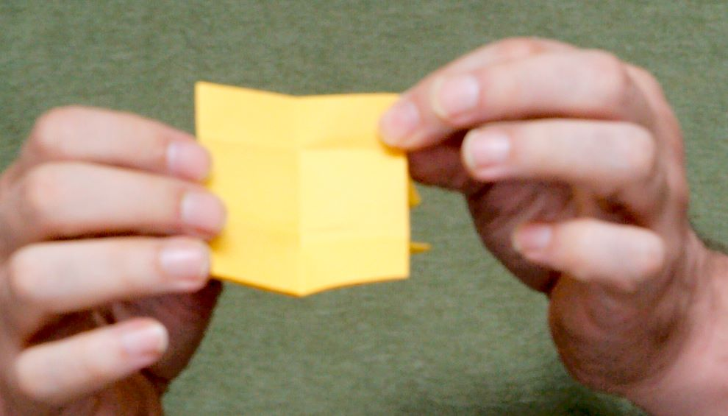
As I continue to unfold, the ripped portion is still directly on an edge visible to the audience. Look to the far right on the rightmost image and you can see a little bit of it. That blends in.
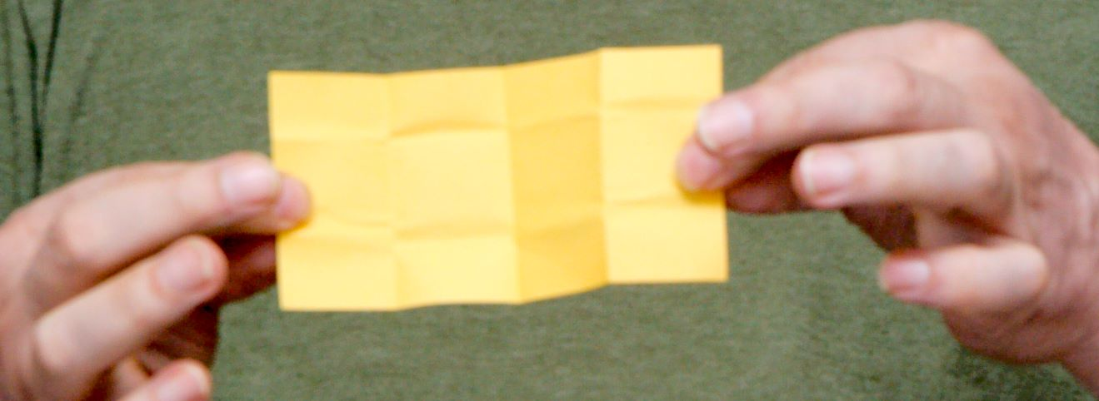
At this point, you must be very careful because it is evident what is happening and if any portion shows it will likely trigger the audience; and it just becomes more apparent as you continue. I can do most of this without spending much time staring at the paper because of practice.
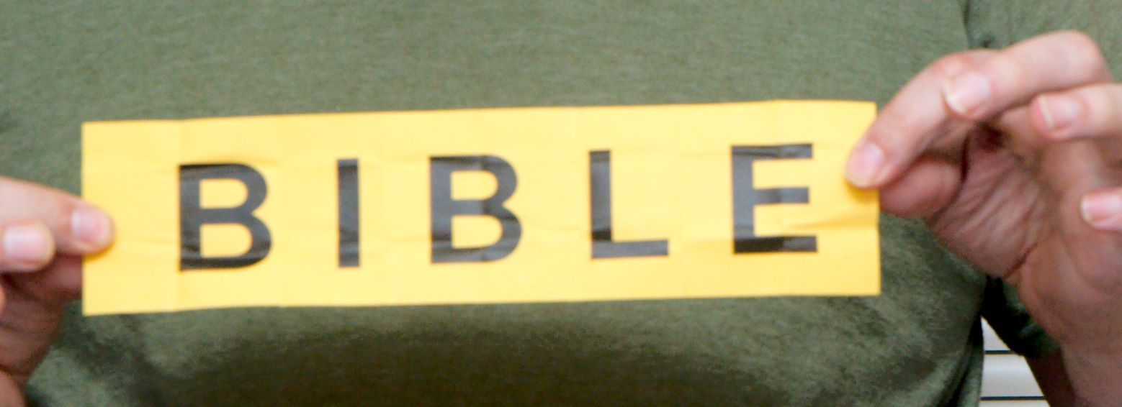
This is the final restore. The torn up pieces are behind the B on the left. If there is a strong back lighting, the torn pieces will show through, not a good thing.
So, what exactly does this look like from the back at this point?
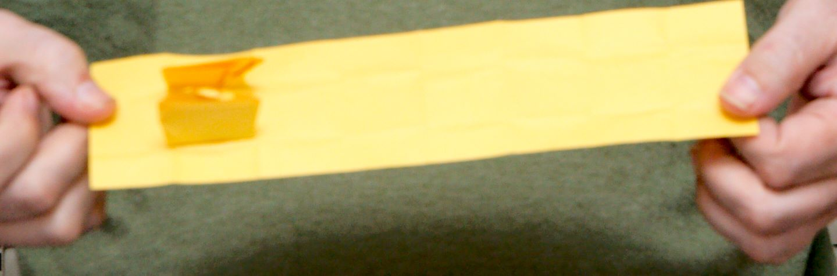
The folds keep the ripped pieces in place without falling out. The rubber cement keep the ripped pieces attached to the back. Depending on how much glue is used, these pieces may come off fairly easily, so, experiment with a few batches that you create, and then be gentle so that you do not knock the ripped pieces off during the presentation.
I finish the trick by folding the restored paper in half such that ripped pieces are sandwiched between the restored paper (so that they are not easily visible). I then carefully dispose of the sheets by say dropping them into my brief case or what ever I have handy. Do not discard this paper where audience members may find them later.
Not that you must also consider how you will produce and present the initial paper when you begin. Preventing the audience from seeing the paper on the back when you begin is just as important at the beginning as in the end. I usually pull the piece from a pocket or brief case with the back to me.
Good Luck!

Holy Bible Coloring Book

Routine by Charles A. Wormsley
Everywhere I go, I find that very people have ever given the Bible an honest investigation.
[hold the Bible coloring book facing the audience]
When it comes to Shakespear, the classics, philosophy, people study these thoroughly. But, when it comes to God's Word, very few people ever even investigate to see whether it is ture. These same peopler are quick to argue against the Bible, and yet, they have never really read it. May will say that the Bible is full of contradictions, and yet, they would not be able to find one if they tried.
Then there are those who have just flipped through the Bible, and have said, “Oh, the Bible, the Bible, it is not reliable!”
[Flip the pages showing an empty book]
There are even those who have gone to college and university, and maybe, had a course in bible literature, but have still never given the Bible a thorough investigation. They may even say, “Oh, I have looked at the Bible from front to back, and back to front and still do not see that it is the Word of God.”
[Flip the pages showing an empty book... again]
But friends, if you are honest with yourself and God, take a look at the Book and pray David's prayer: “Open my eyes that I might behold wondrous things out of Thy Law.”
[Flip the pages showing colorless pictures]
You will find that – yes! There is something in the Bible. Jesus did come to earth, feed the multitudes, do many wonderful things. Jesus died on the cross. Jesus arose from the dead, and He is coming back again.
One other things, friends. You never finish God's Word. You can read it over again and again, and there is still more to read. Boys and girls, if you read “Treasure Island”, you are likely not going to want to read it again for another five years. Adults – if you read an Agatha Christie mystery, you may never want to read it again. Kids, do you wonder why your Grandmother who said that she never exhausted God's Word. It is a wonderful beautiful and colorful book.
[Flip the pages showing colorful pictures]
So friends, make it a habit to investigate, read, and study God's Word every day to have a wonderful, colorful life in Christ.

Routine by Andrew Pitonyak
I usually use a shorter more direct message as follows (with some level of improvisation):
Did you know that some people are not familiar with what is in the Bible.
[Flip the pages showing an empty book]
Some people think that they know what is in the Bible based on what they on TV or hear other people say.
[Flip the pages showing an empty book]
You may be the only real exposure to what is in the Bible for some people.
[Flip the pages showing colorless pictures]
Some people attend church and still do not really know what is in the Bible or have a personal relationship with Jesus.
[Flip the pages showing colorless pictures]
What we really want is that people will have a personal relationship with Jesus.
[Flip the pages showing colorful pictures]
So, you should always live a life according to what Jesus would want and be ready and willing to tell people about Jesus.

Simple Paper Tricks

The Pastor, Nazi, and the Thief
Start with a regular piece of paper and perform the following folds as illustrated below. Fold the top left corner to the right and down such that the left edge aligns with the right edge. Next, fold the top right corner down to the left edge.

Now, fold the sheet in half three times. The final image (to the right) shows the paper after you have unfolded it twice and the dashed lines represent creases in the paper where a fold was performed.

As I tell the story, I begin folding the paper as illustrated above. After making all the folds, I stick the folded paper into my front shirt pocket, and this acts as my ticket to heaven.

The Story
A pastor, a thief, and a Nazi all die at the same time. As they are heading up to the heaven, the thief points to the folded piece of paper and says “what is that?”
The pastor replies, “this is my ticket into heaven.”
The thief says “I sure could use a piece of that ticket.”
So the pastor unfolds the ticket as shown in the far right image above and tears along the far right fold and hands those pieces to the thief.
The Nazi then speaks up and says “I was pretty bad, and I would really like a piece of that ticket as well.”, so, the Pastor tears along the right most fold and hands the removed piece to the Nazi.
The thief, being a greedy person, says, “you know, I was pretty bad, could I have another piece of your ticket?”, so the Pastor rips along the final fold and hands the thief the portion from the right.
At this point, they all arrive at heavens gate and God says “Tickets Please!”
The thief hands his pieces to God who then begins assembling them. At this point, you can choose what to say, perhaps something like “Hmmm, what do we have here, very unusual”, as you assemble the bits to spell out HELL.
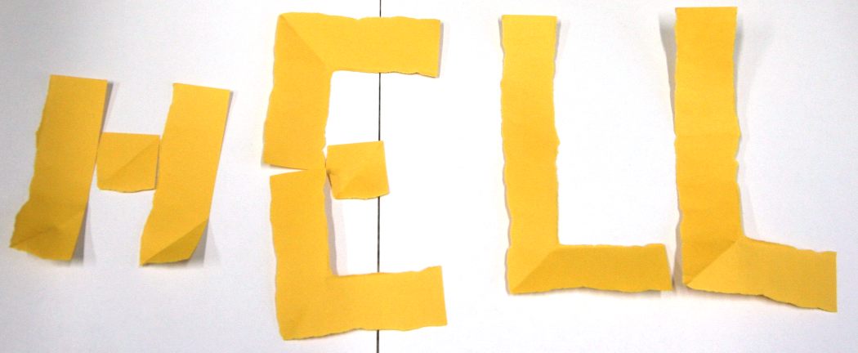
After spelling out HELL, say “I am sorry, I cannot let you in.”
Next, God takes the ticket from the Nazi and starts to assemble the pieces. The Nazi is very nervous, but is sure that it cannot spell hell, because there are not as many pieces.
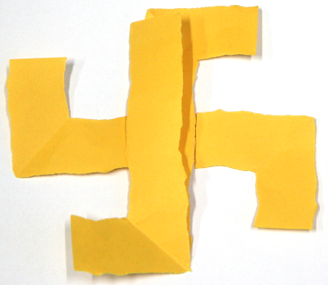
After creating a Swastika, God says “I am sorry, I cannot let you in.”
Finally, God takes the ticket from the pastor, unfolds it, reveals a cross, and says “welcome to heaven!”
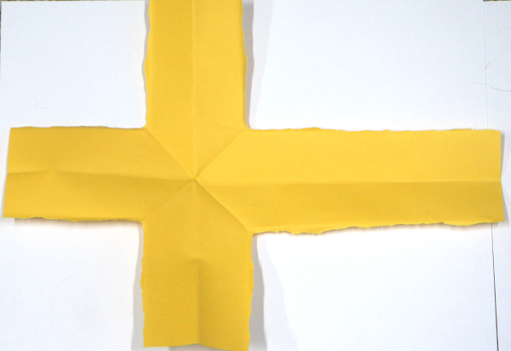

Alternate
If you want to simply create a cross, then you do not need to do all the folds, you can simply approximate where to do one tear to create a cross.

